M.D. Asif

Patel Nagar, 2nd cross,

Hospet, Karnataka,

India-583201.

M: 8660163894

mdasifasif402@gmail.com

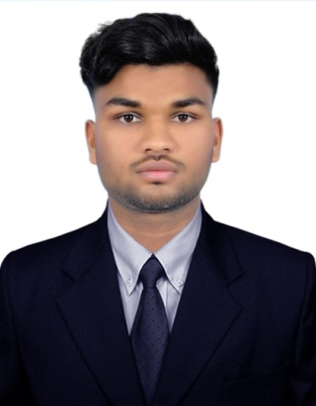

PROFESSIONALSUMMARY

Hard working and passion at e job seeker with strong organizational skills eager to secure entry-level Modeller position. Ready to help team achieve company goals. To seek and maintainfull-timepositionthatoffersprofessionalchallengesutilizinginterpersonalskills,excellenttimemanagementandproblem-solvingskills.

EDUCATIONALBACKGROUND

High School
Mahila Samaj School. Hospet.
Batch: 2018 - 2019

Diploma (Mechanical Engineering)
Sir M Vishveshwaraya Polytechnic. Hospet.
Batch: 2019 - 2022

SKILLS
Auto cad
Mcquay duct sizing
Mcquay Pipe sizing air Terminals election beta Software

LANGUAGESKNOWN
English Hindi Kannada

PROFESSIONAL EXPERIENCE

Hvac Modeller / Draftsman
Elevate HVAC Engineers Pvt Ltd., Bangalore.
2022- to-Current
As HVAC drafts man my responsible were creating detailed technical drawings and plans related to heating, ventilation, and air conditioning (HVAC) systems. Their job description typically includes:

- Coordinated Drawing Preparation: Produced detailed and coordinated HVAC drawings by converting single-line diagrams into shop drawings.
- Duct and Pipe Sizing: Conducted precise calculations for duct and pipe sizing.
- Incorporating Components: HVAC components, including dampers, VCDs (Volume Control Dampers), and insulation, into drawings to ensure system functionality and energy efficiency.
- Bill of Quantity (BOQ) Preparation: Prepared BOQ sheets to item izeall materials and components needed for HVAC installations.
- Page Setup: configuring page layouts, including title blocks, scales, and sheet numbering.
- Annotations and Tags: Added informative annotations, tags, and labels to drawings for clarity and ease of reference.
- Collaboration: Collaborated effectively with engineers and project teams to address design modifications and ensure integration of HVAC system sin to building plans.

SELF DECLARATION
I hereby declare that the information furnished above is true to the best of my knowledge.

(M.D.Asif)

M: 8660163894.

