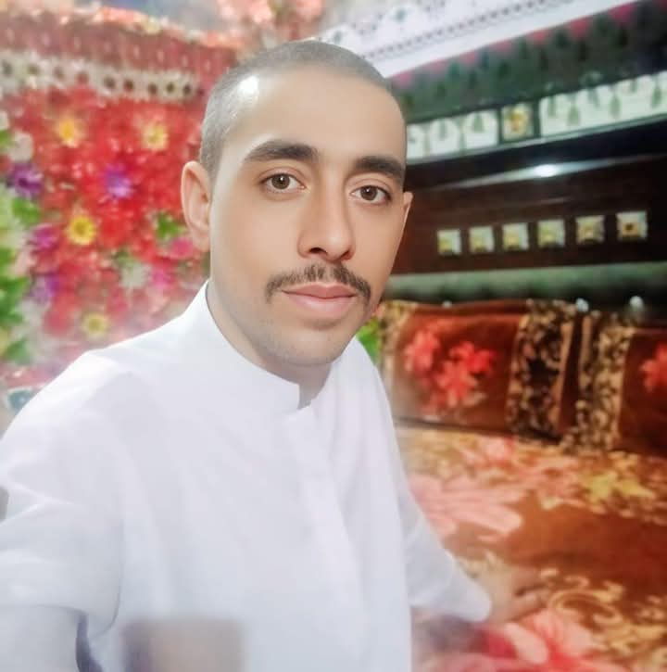

Imran Ali
**Father's Name:** Shahnawaz
**Date of Birth:** 22 April 1991
**Passport No:** SB1829941
**Gender:** Male
**Marital Status:** Married
**Religion:** Islam
**Nationality:** Pakistani
**Contact:** +92 300 3129629
**Email:** imranaligur@gmail.com
**Address:** Village Ameer Bux Gurgage, P.O. Daharki, Taluka Daharki, District Ghotki, Sindh, Pakistan
**Languages:** Sindhi, Urdu, English

Education
Intermediate (8th Pass)

Work Experience
8 years of experience in scaffolding.

Hobbies
Scaffolding-related activities, general labor work.

